**Assessment: Finding a missing airplane**

**Background**

Bayesian search theory is the use of Bayes' Theorem to find lost objects. It has been used to find planes crashed at sea, sunken submarines, missing people and more. Prior assumptions about the probability of finding the object in various locations are continually revised as the search proceeds.

A search team is tasked with finding a crashed plane. Their initial data suggest the plane is found somewhere within one of four areas with the following probabilities:

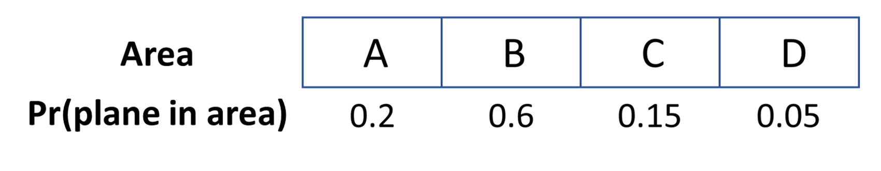

The team can search one area per day and will always search the area with the highest probability. When the team searches an area, there is a 90% chance that they find a plane if one is present and a 10% chance that they overlook the plane. (There is always a 100% chance of not finding a plane if one is not present in the area.)

Use Bayes' Theorem to determine where the team should search on the second day if necessary and the probability of finding the plane within 2 days.

**Equation summary**

Pr(plane in A)=0.2

Pr(plane in B)=0.6

Pr(plane in C)=0.15

Pr(plane in D)=0.05

Pr(plane not found in area | plane in area)=0.1

Pr(plane not found in area | plane in different area)=1

**Pre-exercise code**

Report your answers to 3 significant digits:

options(digits = 3)

**Questions?**

Ask any questions about this assessment in the discussion forum at the bottom of this page.

**Question 1**

3/3 points (graded)

On day 1, the team will search area B. The probability that the plane is in area B is Pr(plane in B) = 0.6.

What is the probability the plane is not in B?

correct

0.4 Loading

What is the probability the plane is in B but is not found?

correct

0.06 Loading

What is Pr(plane not found in B), the probability the plane is not found in B on day 1?

correct

0.46 Loading

You have used 1 of 5 attempts Some problems have options such as save, reset, hints, or show answer. These options follow the Submit button.

**Question 2**

1/1 point (graded)

Suppose the plane will not be found on day 1. What is the equation for Pr(plane in B | plane not found in B), the posterior probability that the plane is in area B given that it is not found in area B on day 1?

Select the correct equation for Pr(plane in B | plane not found in B):

Pr(plane not found in B)×Pr(plane in B)Pr(plane not found in B | plane in B)

Pr(plane not found in B | plane in B)× Pr(plane in B)Pr(plane not found in B)

Pr(plane not found in B | plane in B)×Pr(plane not found in A)Pr(plane not in A)

Pr(plane not found in B | plane in B)×Pr(plane not found in B)Pr(plane in B)

correct

You have used 2 of 2 attempts Some problems have options such as save, reset, hints, or show answer. These options follow the Submit button.

**Question 3**

3/3 points (graded)

Use Bayes' Theorem to calculate the posterior probabilities of finding the plane in each of the 4 grid locations. Recall that area B will be searched on day 1.

What is the posterior probability that the plane is in area B given that it is not found on day 1?

correct

0.130 Loading

What is the posterior probability that the plane is in area C given that it is not found on day 1?

correct

0.326 Loading

Which area has the highest posterior probability and should be searched on day 2?

A

B

C

D

correct

You have used 1 of 5 attempts Some problems have options such as save, reset, hints, or show answer. These options follow the Submit button.

**Question 4**

3/3 points (graded)

Before the search begins, you have been asked to report the probability that you find the plane within two days.

What is the probability of finding the plane on the first day?

correct

0.54 Loading

What is the probability that the plane is not found on the first day but is found on the second day?

On day 2, you will search the region that had the highest posterior probability in question 3. Make sure you multiply the probability of a successful search on day 2 by the probability that the plane is not found on day 1.

correct

0.18 Loading

What is the probability that the plane is found within 2 days?

correct

0.72 Loading

You have used 2 of 5 attempts